**Impact of IoT-Based Temperature Monitoring System in Critical Industries**  
Temperature monitoring is crucial in high-risk environments such as **paint industries, factories with heavy machinery, ICUs, and remote locations** where manual monitoring is impractical and hazardous. In industrial settings, **overheating of machinery can lead to equipment failure, fires, or explosions**, causing **significant financial losses and endangering lives**. An **IoT-based real-time temperature tracking system** with automated alerts ensures **early detection of overheating**, **preventing accidents and reducing maintenance costs**. In **paint and chemical industries**, where **flammable substances are present**, even a **slight temperature rise can trigger chemical reactions or explosions**. This system **provides instant notifications** and can be integrated with **automated shutdown mechanisms**, significantly **enhancing workplace safety**. Similarly, in **ICUs and neonatal care**, maintaining the **right temperature** is **critical for patient survival**. Continuous monitoring with **immediate alerts** allows medical staff to **respond quickly to fluctuations**, **preventing life-threatening conditions**. In **remote locations** such as **mines, oil rigs, and cold storage facilities**, **real-time monitoring eliminates the risk of manual errors and delays**. By wirelessly **transmitting data to cloud platforms like ThingSpeak**, decision-makers can **act swiftly**, ensuring **human safety, equipment longevity, and operational efficiency**.

**Augmented Reality (AR) further enhances IoT-based temperature monitoring** by providing **real-time visualization of critical data** in an **interactive 3D environment**. In **factories, chemical plants, and ICUs**, AR **overlays temperature readings** directly onto **physical machinery or patient monitors**, enabling technicians and medical staff to **assess critical conditions instantly** without manually checking sensors. This **reduces response time in emergencies** and **simplifies complex data interpretation**. In **hazardous environments** like **oil refineries, mines, and remote industrial sites**, AR eliminates the need for **direct human intervention** by allowing **remote monitoring** of equipment using **AR-assisted digital twins**. Supervisors can **interact with 3D models of machines**, analyze **real-time temperature variations**, and **trigger emergency responses** from a safe distance. Additionally, **AR integration with ThingSpeak and IoT dashboards** provides managers with **immersive access to live sensor data**, improving **decision-making, predictive maintenance, and proactive problem resolution**. By integrating **IoT-based temperature monitoring with AR**, industries can **reduce operational risks, enhance industrial safety standards, and prevent catastrophic failures**, ultimately **saving lives and optimizing efficiency**.

**Algorithm: AR-Based IoT Temperature Monitoring System**

**1. Initialization**

1. Start the Unity Augmented Reality (AR) environment.
2. Assign 3D model components to be monitored within the AR scene.
3. Establish a connection with the IoT cloud platform (ThingSpeak API) for real-time temperature data retrieval.

**2. Data Acquisition**

1. Initiate an HTTP request to the ThingSpeak API to fetch the latest sensor readings.
2. Retrieve the JSON response containing temperature data.
3. Parse the response and extract the most recent temperature value.

**3. Data Processing and Condition Analysis**

1. Evaluate the temperature value against predefined threshold limits:
   * **If** the temperature exceeds the upper threshold (**High-Risk Zone**)
     + Update the object color to **Red** (Indicating a hazardous condition).
   * **Else if** the temperature is within the normal operating range
     + Update the object color to **Green** (Indicating a safe condition).
   * **Else if** the temperature falls below the lower threshold
     + Update the object color to **Blue** (Indicating low-temperature conditions).

**4. AR Visualization and User Interface Updates**

1. Overlay real-time temperature data onto the corresponding AR model components.
2. Update the AR UI to display live temperature readings dynamically.
3. Visually highlight affected machinery or components based on temperature variations.

**5. Alert and Notification System**

1. **If** the recorded temperature surpasses critical safety thresholds:
   * Log a warning message within the Unity console.
   * Trigger an alert notification (e.g., visual indicator, alarm, or push notification).
   * Optionally, integrate an automated shutdown mechanism to prevent potential hazards.

**6. Continuous Monitoring and Data Refresh**

1. Wait for a predefined update interval (e.g., 16 seconds).
2. Repeat steps **2–5** to ensure continuous real-time monitoring.

**7. System Exit and User Navigation**

1. **If** the user selects the “Back to Menu” option:
   * Terminate background data retrieval processes.
   * Redirect the user to the main menu interface within the Unity application.

**End of Algorithm**

This structured approach ensures efficient monitoring, visualization, and proactive response to temperature variations in industrial and high-risk environments using IoT and AR technologies.

II. SUMMARY

Augmented Reality (AR) has emerged as a transformative technology across various domains, revolutionizing interactions between users and digital environments. Its applications span from healthcare and education to industrial training, navigation, and IoT-based smart systems. AR enhances real-world perception by overlaying digital information onto physical spaces, enabling intuitive interaction and improved decision-making. The development of AR applications has been facilitated by platforms like Unity and Vuforia, providing developers with tools to create immersive experiences [13]. As AR continues to evolve, its integration with cloud computing, artificial intelligence (AI), and the Internet of Things (IoT) further expands its potential applications across industries.

In healthcare, AR-based mobile applications have provided innovative solutions for medical assistance. One such application focuses on **insulin intake management**, offering real-time guidance to diabetic patients through interactive AR interfaces [1]. AR has also been explored for **posture detection in medical training**, utilizing YOLO-6D-based object recognition to assess postural accuracy and provide feedback, thereby improving surgical precision and rehabilitation therapies [2]. In ICUs and neonatal care, AR-based monitoring systems enhance patient care by allowing medical professionals to visualize real-time physiological data overlaid onto physical patient monitors, reducing response times in emergencies.

In the **education sector**, AR has transformed traditional learning methodologies by providing interactive and immersive learning experiences. Research has demonstrated that AR significantly enhances **geometry learning for elementary school students** by allowing them to manipulate 3D geometric models, thereby improving spatial reasoning and comprehension [5]. Similarly, AR has been applied in **electrical fundamentals education**, where students can visualize electric circuits, interact with components, and conduct virtual experiments through an AR-based mobile physics application [6, 12]. These applications bridge the gap between theoretical learning and practical application, making complex concepts more accessible.

Industrial training has also greatly benefited from AR technology. **Focus AR**, a study on **focus-based mobile AR applications in industrial training**, highlights how AR enhances hands-on learning by simulating real-world scenarios and providing step-by-step interactive guidance [3]. This has been particularly effective in **distant maintenance applications**, where AR enables remote troubleshooting and repair of machinery by overlaying instructional guides onto physical equipment [4]. This approach significantly reduces operational downtime and minimizes the need for on-site expert intervention. Additionally, AR-based **CNC surface roughness machine training modules** assist operators by providing real-time AR overlays of machine settings and parameters, enhancing precision in manufacturing processes [11].

AR has also revolutionized **navigation and spatial awareness applications**. AR-powered **campus navigation systems** leverage ARCore technology to provide real-time guidance for both indoor and outdoor spaces, allowing students and visitors to navigate large institutions effortlessly [7]. In the field of cultural preservation, AR has been utilized to enhance **national museum heritage visualization**, enabling users to experience historical artifacts and exhibitions interactively through their mobile devices [8]. Such applications create engaging and informative experiences, enriching cultural education.

The retail and consumer sector has witnessed significant advancements with AR-powered applications. **Smart Fitting**, an AR-based mobile application, enables users to virtually try on clothing and accessories, eliminating the need for physical fitting rooms and enhancing the online shopping experience [9]. Similarly, **AR-Food**, an **augmented reality food diary application**, allows users to track and visualize their meals in 3D, facilitating better dietary management and collaboration with nutritionists [10]. These applications showcase AR’s potential in enhancing personalized consumer experiences.

The integration of AR with **IoT and energy monitoring systems** has led to the development of intelligent control solutions. An **AR-based mobile application for energy monitoring and IoT device control** enables users to visualize real-time power consumption data and interact with smart home appliances through AR interfaces [11]. This enhances energy efficiency and provides intuitive control over IoT-connected devices. Furthermore, AR has been implemented in **electrical engineering education**, allowing users to explore **electrical circuits interactively** through augmented overlays, improving conceptual understanding and practical application [12].

Developing AR applications has become more accessible with frameworks such as **Unity and Vuforia**, which provide robust tools for creating AR experiences [13]. A **step-by-step guide** to building AR applications details the process of integrating 3D models, implementing marker-based tracking, and optimizing rendering for mobile platforms [14]. As AR technology advances, its combination with cloud computing and AI-driven analytics is expected to enhance real-time data processing and interaction capabilities.

Future developments in AR will likely focus on **enhanced real-time visualization, AI-powered interaction, and cloud-based AR platforms**. As research continues to push the boundaries of AR applications, industries will experience improved **operational efficiency, enhanced user experiences, and increased safety standards** [15-20]. The synergy of AR with **IoT, AI, and big data analytics** will drive further innovations, enabling more intelligent and adaptive systems across multiple domains. With ongoing advancements, AR remains a critical component of modern technology, shaping the future of healthcare, education, industry, and consumer applications.

FLOWCHARTS:

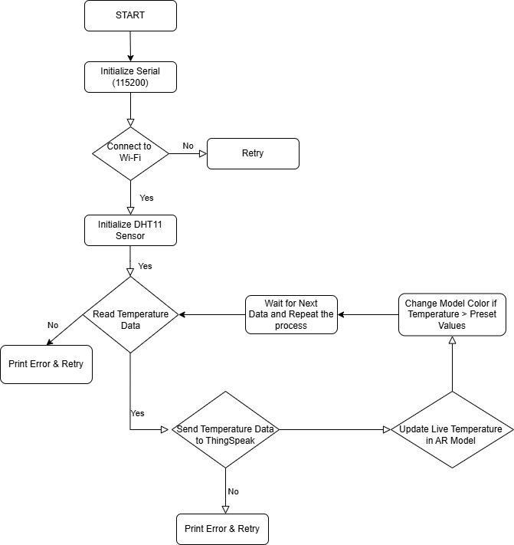

2 :-

